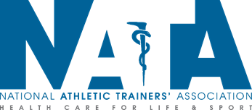

**NATA National Awards Update**

Due to the decision not to hold the in-person 71st NATA Clinical Symposia & AT Expo in Atlanta, the NATA Honors & Awards Committee, with the support of the NATA Board of Directors, voted to postpone the recognition of national award winners until NATA 2021 in Orlando. In addition, after thoughtful consideration of the potential impact on recognition efforts and timing, the 2020-2021 nomination and application cycle for national awards will be suspended and nominations will resume in August 2021.

These decisions were made in an effort to maintain the prestige of the Hall of Fame and national awards, and to provide the appropriate level of recognition for the highest honors bestowed upon NATA members. Alternatives to the standard recognition process that do not include an in-person presentation or the various recognition efforts for national award winners and Hall of inductees (award presentation at the General Session, on-stage and backstage photos, the Hall of Fame induction ceremony, Hall of Fame breakfast with ring presentation, public display of tribute videos, the Hall of Fame booth display, etc.), would deny each award recipient the recognition and experience that they have earned through their dedication to the Association.

While we understand that members who were planning to nominate a colleague or apply for an award this year may be disappointed that they will have to wait another year, it is important to keep in mind that national awards are career or lifetime achievement awards. Each award requires at least 15 years of service for non-members and 20 to 40 years of service and membership for NATA members. Ultimately, the committee determined that a one-year suspension should not prevent a qualified candidate from eventually receiving an award, especially when many jobs and service and volunteer opportunities are currently halted or minimized due to COVID-19. While the NATA Honors & Awards committee members are aware of the possible impact on future candidates and potential award winners, their obligation is to ensure those who were already selected for awards are adequately recognized.