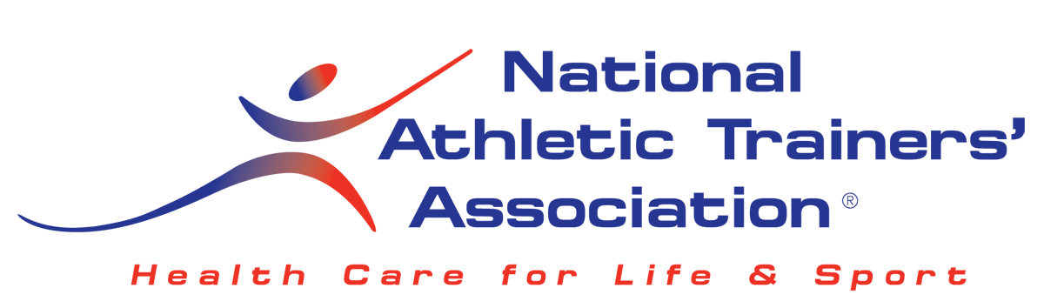

Athletic Training in the Outpatient Rehabilitation Clinic Setting:
An FAQ for Athletic Trainers

Athletic trainers (ATs) are routinely employed in hospitals, clinics, and orthopedic sports medicine outpatient rehabilitation practices. ATs working in these settings improve productivity, patient outcomes and satisfaction.
What is the Role of an Athletic Trainer in an Outpatient Rehabilitation Clinic?
Today, many outpatient rehabilitation clinics are choosing to hire athletic trainers as a part of their clinical staff. Athletic trainers provide value to the practice through their skills in taking patient histories, performing evaluations, providing instruction on exercise prescriptions, industrial rehabilitation and general patient education.
The outpatient rehabilitation clinic is a specialized setting within the athletic training field. Athletic trainers working in this setting still work under their state license and scope of practice. No extra certifications or licenses are required.
ATs increase productivity and efficiency with:

- Performing evaluations and special tests – depends on state practice act
- Educating patients and answering questions
- Industrial/Back to Work Programs
- Ergonomic Assessments
- DME/brace fitting
- Performing therapeutic exercise
- Administering gait training
- Instructing in home exercise programs

Can I bill for my services?

Check your practice act, as well as your employer, for guidelines and/or limitations. CPT codes are applicable to any licensed clinical practitioner, with the exception of the evaluation codes. Athletic trainers must use 97005 and 97006.

What about third party reimbursement or other ways to generate revenue?

Depending on your state practice act and employer, this is indeed possible. Third Party Reimbursement is a payor issue, so the insurance company must be willing to reimburse you for your services. This varies from state to state, and is constantly changing.

An AT can also generate revenue in other ways: outreach athletic training contracts, cash payments for treatment or preventative care, exercise instruction, performance enhancement, fall reduction programs, and many others. As a licensed healthcare provider, there are many ways for the athletic trainer to market his/her services and generate revenue from performing these services.

Do I have to work under the supervision of a physical therapist?

No, this is typically an employer issue, and should be discussed prior to being hired. The team approach to treatment and rehabilitation is the best model in any outpatient rehabilitation facility.

Do I have to perform outreach athletic training services to work in an outpatient rehabilitation clinic?

It will vary from clinic to clinic. Many outpatient rehabilitation facilities do utilize ATs to work outreach athletic training contracts, using the AT in the clinic when they are not at their outreach facility. Each employer has a different model, so understanding the model you will be working in and what is expected of you, is extremely important.

State Practice Act:
Check the state practice act link below. If your state has a very restrictive practice act, you need to research the employment opportunity and speak with a hiring authority, probably the administrator for the physician practice.
http://www.nata.org/state-practice-acts
Click here for more information on state regulatory boards:
http://cf.nata.org/legislators/map.htm?q=state-government/regulatory-boards
If you need additional information contact Judy Pulice at the NATA Office: JudyP@nata.org

Reimbursement:
Depending on the insurance company, you may be able to bill for services. For more information visit NATA Reimbursement:

http://www.nata.org/revenue-resources/reimbursement/reimbursement-faqs

Direct Billing vs. Incident to Billing:
If the patient is covered by insurance other than Medicare, you may be able to bill for services. An AT may bill directly to an insurance company if they are recognized or credentialed by the payer, otherwise AT services are billed by the physician as incident to his/her services.
If you need more information contact Patty Ellis at the NATA Office: PattyE@nata.org

What Are Incident to Services?
Incident to a physician's professional services means that the services or supplies are furnished as an integral, although incidental, part of the physician's personal professional services in the course of diagnosis or treatment of an injury or illness. When the physician practice bills for incident to services, it is billed under the physician’s or clinic’s NPI, the documentation should show who actually performed the service.

Practice Profiles: ATs in Orthopedic Offices:

http://www.nata.org/sites/default/files/practice-profile-orthopedic-offices.pdf

NATA Career Center:
To find a job in a physicians office please go to the NATA Career Center:
http://www.nata.org/career-center

Physical Medicine and Rehabilitation Codes:

The athletic training evaluation and re-evaluation codes (97005-6) should be used by athletic trainers. The remaining physical medicine and rehabilitation codes (PMR) may be used by any physician or health care provider. Go here for a comprehensive list of the most frequently used billing codes by ATs:

http://www.nata.org/sites/default/files/RehabCodes_0.pdf

Familiarize yourself with pertinent parts of the CMS guidelines on outpatient therapy services and documentation.

http://www.cms.hhs.gov/manuals/Downloads/bp102c15.pdf

2008 Salary Survey information:

http://cf.nata.org/salarysurvey2008/index.htm

Job Descriptions of ATs Working in the Physician Office Setting:

http://www.nata.org/employers/sample-job-descriptions/clinical-athletic-trainer

http://www.nata.org/sites/default/files/PhysicianOffices.pdf

Other Resources:

http://www.aaos.org/news/aaosnow/oct08/managing4.asp

Other Benefits for Physicians Using ATs in the Physician Office Setting:

Time savings – Athletic trainers help move patients faster through the appointment, evaluation and treatment process. This makes the physician more productive.

Patient satisfaction – Patients like the personal care and attention that athletic trainers provide.

Revenue – In some cases, athletic training services are reimbursable by insurance companies, services are either directly billed or billed incident-to physician services. Physical medicine and rehabilitation codes (97xxx CPT codes) are the most common codes used.

Patient education – Understanding the path to recovery helps put patients’ minds at ease and improves both compliance and satisfaction. The athletic trainer usually ensures the patient understands the physician’s instructions and is available later for follow-up questions from the patient. This AT-patient bond is important to outcomes and satisfaction.

Additional Information:
1. Academic Qualifications:
- Minimum:
  - Bachelor Degree with major in athletic training, holds the ATC (Athletic Trainer, Certified) credential
  - Experience with injury evaluation and rehabilitation
- Preferred:
  - Masters Degree in athletic training or related area if the bachelor’s is in athletic training. 2-3 years of experience with injury evaluation and implementing comprehensive injury management strategies
  - Computer skills involving PowerPoint, Excel, and Access
  - Certified Orthopedic Technologist
2. Additional Certifications:
  - NBCOT
    - The National Board for Certification of Orthopaedic Technologists (NBCOT) examination for orthopaedic technologists measures entry-level knowledge and skill in Orthopaedic Technology. Successful passing of the NBCOT Certification Examination signifies an entry level of knowledge of the following categories in the specialty of orthopedic technology. For more information regarding the exam please see the website at www.nbcot.net
  - Certified Orthotic fitter
    - BOC is an independent, not-for-profit agency that certifies orthotists, prosthetists, pedorthists, orthotic and mastectomy fitters and accredits their facilities. Please visit this website for more information: www.bocinternational.org
3. Work Load:
- Hours: 40 -45 hrs/wk, usually Monday – Friday only. Work Load: Work load remains stable throughout the year with slow periods around the Christmas holidays. Increasing volume during the summer months and the fall.
- Travel: None
4. Job Profile:
- Day-to-Day:
  - Injury evaluation, Injury prevention, Pre-participation physicals, Injury Management, Injury rehabilitation, Health education, Sports nutrition, Sports training and conditioning, Report writing & documentation
  - No emergency care
Supervision: Supervising Physician(s)
- Job Security:
  - Continuance of job depends upon ATs job performance and financial performance of the clinical team.
5. Supervision:
- Director - AT
- Physician
6. Tips for getting a job in this setting:
- Develop a strong rapport with physician(s). Diversify your clinical skills and experiences Remain on the cutting edge of sports medicine. Obtain education in areas of other health care. Develop good skills in evaluation and management of musculoskeletal injuries. Improve your ability to work and communicate with many types of people/personalities.
- Find the busiest practice with the longest waiting room time and offer your services.
Q&A on Reimbursement:

Available for NATA members at:

http://www.nata.org/revenue-resources/reimbursement/reimbursement-faqs

